National Conference on Technology for Sustainable Rural Development

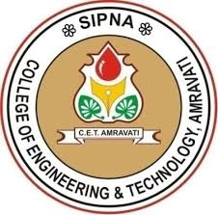
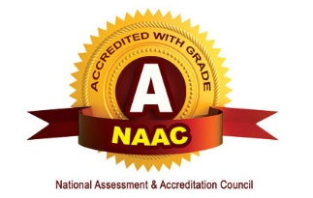
(NCTSRD-2020)
Organized By
Department of Mechanical Engineering,
Sipna College of Engineering and Technology, Amravati (M.S)
Conference Link: http://www.sipnaengg.ac.in/nf-2020-2/

COPYRIGHT TRANSFER FORM
It is required to obtain a written confirmation from authors in order to acquire copyrights for papers published in the proceedings of “National Conference on Technology for Sustainable Rural Development” (NCTSRD-2020) which will be held on 27th April 2020.

Paper ID
Paper Title
Registration Details

Name of Author | E-mail & Contact No. | Organization Detail Address | Signature
Corresponding Author
Co-Authors No.1
Co-Authors No.2

Copyright Transfer Statement
The copyright to this article is transferred to NCTSRD-2020 if and when the article is accepted for publication. The undersigned hereby transfers any and all rights in and to the paper including without limitation all copyrights to NCTSRD-2020. The undersigned hereby represents and warrants that the paper is original and that he/she is the author of the paper, except for material that is clearly identified as to its original source, with permission notices from the copyright owners wherever required.
We declare that:
- I/We hereby declare that the material being presented by me/us in this paper is our original work, and does not contain or include material taken from other copyrighted sources. Wherever such material has been included, it has been clearly indented or/and identified by quotation marks and due and proper acknowledgements given by citing the source at appropriate places.
- The paper, the final version of which I/We enclose, is not substantially the same as any that I/we have already published elsewhere.
- I/we have not sent the paper or any paper substantially the same as the enclosed one, for publication anywhere else.
- The submitted/enclosed camera-ready paper is thoroughly proof read by me and in conformity with the instructions for authors communicated to me.

Furthermore, I/We hereby transfer the unlimited rights of publication of the above mentioned paper in whole to the NCTSRD-2020. The copyright transfer covers the exclusive right to reproduce and distribute the article, including reprints, translations, photographic reproductions, microform, electronic form (offline, online) or any other reproductions of similar nature. This agreement is to be signed by at least one of the authors who have obtained the assent of the co-author(s) where applicable. After submission of this agreement signed by the corresponding author, changes of authorship or in the order of the authors listed will not be accepted.

Please fill-up the copyright form, sign and send it back at the email id: sipnamech.nctsrd@gmail.com.

