Sipna College of Engineering & Technology, Amravati
<Name of Department>

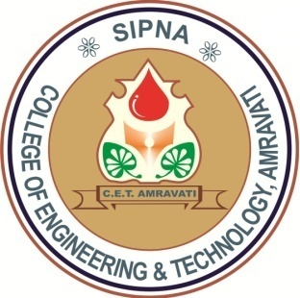
CERTIFICATE
This is to certify that the dissertation titled
“<Title of Dissertation>”
has been successfully completed in session 2018-19 by
<name of student>
in recognition to the partial fulfillment for the degree of
Master of Engineering
(<name of branch>),
Sant Gadge Baba Amravati University, Amravati.

<name of guide> <name of HoD>
Guide Head of Department

Principal

