Sipna College of Engineering & Technology, Amravati
Department of Computer Science and Engineering

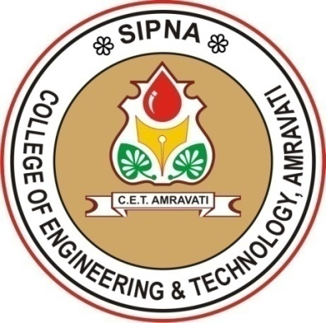

CERTIFICATE

This is to certify that
Name of Student(s)
has satisfactorily completed the project work towards the Bachelor of Engineering Degree of Sant Gadge Baba Amravati University, Amravati in Computer Science & Engineering discipline on the topic entitled “Topic name”, during the academic year 2020-2021 under my supervision and guidance.

Date:

Name of Guide Dr. V. K. Shandilya

Guide Head of Department

Dr. S. M. Kherde
Principal

